**MAIN-PROJECT**

**AIM:** [MAIN PROJECT-1]

Developing a functionality to connect a form to a database using PHP and MySQL, allowing users to submit and store applicant information, including attributes such as applicant name, gender, qualification, age, date of birth, etc. The form will utilize HTML for input fields and PHP for establishing the connection to the database.

**KEY-REQUIREMENTS:**

1. Design an HTML form with input fields for attributes like applicant name, gender, qualification, age, and date of birth.

2. Utilize appropriate HTML input field types and attributes for each attribute, ensuring data integrity and usability.

3. Implement PHP code to validate the form inputs, checking for completeness and correctness before proceeding.

4. Establish a connection to the MySQL database using PHP and appropriate database credentials.

5. Create a table in the MySQL database to store the applicant information, defining the appropriate columns and data types.

6. Insert the validated applicant data into the MySQL database table upon successful form submission.

**CODES:**

**HTML: APPLICANT REGISTRATION.HTML**

<!DOCTYPE html>

<html>

<head>

<title>R E G I S T R A T I O N</title>

<link rel="stylesheet" href="styl.css">

</head>

<body>

<center>

<div id="form_div">

<h2> APPLICANT REGISTRATION </h2>

<p><b>NOTE:PLEASE FILL ALL THE DETAILS CAREFULLY</b></p>

<br>

<form action="Form_file.php" method="POST">

<label for="applicant_name">NAME(fullname): </label>

<input id="applicant_name" type="text" name="applicant_name" autofocus requried

autocomplete="false" />

<br><br>

<label for="applicant_age"> AGE: </label>

<input id="applicant_age" type="text" name="applicant_age" autofocus requried

autocomplete="false" />

<br><br>

<label for="applicant_phno">PHNO: </label>

<input id="applicant_phno" type="number" min="1000000000" max="9999999999" name="applicant_phno" autofocus requried

autocomplete="false" />

<br><br>

<label for="applicant_email">EMAILID: </label>

<input id="applicant_email" type="text" name="applicant_email" autofocus requried

autocomplete="false" />

<br><br>

<label>GENDER: </label>

<input id="male_gender" type="radio" name="gender" value="male" autofocus required autocomplete="false">

<span id="male_gender_label" for="male_gender" >Male </span>

<input id="female_gender" type="radio" name="gender" value="female" autofocus required

autocomplete="false">

<span id="female_gender_label" for="female_gender">Female </span>

<br><br>

<label for="university">UNIVERSITY: </label>

<input id="university" type="text" name="university" autofocus requried

autocomplete="false" />

<br><br>

<label for="DOB">DATE OF BIRTH: </label>

<input id="DOB" type="date" name="DOB" autofocus required autocomplete="false"/>

<br><br>

<label for="gardian_name">Parent/GUARDIAN NAME: </label>

<input id="gardian_name" type="text" name="gardian_name" autofocus required autocomplete="false"/>

<br><br>

<label for="applicant_add">ADDRESS: </label>

<input id="applicant_add" type="text" name="applicant_add" autofocus requried autocomplete="false"/>

<br><br>

<input id="submit_button" type="submit" name="submit_button" value="Register"/>

<br><br>

</form>

</div>

</center>

</body>

</html>

**CSS: styl.css**

body{

background:rgb(20,28,41);

}

h2{

font-family:"arial";

color:white;

background:rgb(25,53,107);

padding:20px 20px 20px 20px;

}

label{

font-family:"courier new";

color:black;

font-size:15;

display:inline-block;

width:30%;

text-align:right;

padding-right:20px;

}

input,select{

outline: 0px;

background:transparent;

margin-bottom:20px;

width:60%;

border:none;

font:inherit;

border:1px black solid;

border-width: 0px 0px 1px 0px;

}

div#form_div{

border:20px;

background-color:white;

padding:20px 50px 10x 50px;

width:40%;

border-radius: 50px;

}

input#male_gender,#female_gender{

width: auto;

}

#male_gender_label,#female_gender_label{

display: inline-block;

text-align: left;

width: 25.5%;

}

p{

font-size:11px;

background:gray;

width:100%;

}

input#submit_button{

color:white;

outline: 0px;

border: 1px black solid;

background-color:rgb(20,28,41);

border-radius: 5px;

padding: 5px;

margin-left: 75%;

width: auto;

margin-top: 10px;

margin-bottom: none;

}

**PHP: Form_file.php**

<?php

$host= "127.0.0.1";

$username = "root";

$password = "";

$db_name = "mydb";

$conn = mysqli_connect($host, $username, $password,$db_name);

if (!$conn) {

die("Connection failed: " .mysqli_connect_error());

}

$applicant_name = $_POST['applicant_name'];

$applicant_age = $_POST['applicant_age'];

$applicant_phno = $_POST['applicant_phno'];

$applicant_email = $_POST['applicant_email'];

$gender = $_POST['gender'];

$university = $_POST['university'];

$DOB = date("Y-m-d",strtotime($_POST['DOB']));

$parent = $_POST['gardian_name'];

$address = $_POST['applicant_add'];

$mysql="INSERT INTO applicant_data (applicant_name,applicant_age,applicant_phno,applicant_email,gender,university,DOB,parent,address) VALUES('{$_POST['applicant_name']}','{$_POST['applicant_age']}','{$_POST['applicant_phno']}','{$_POST['applicant_email']}','{$_POST['gender']}','{$_POST['university']}','{$DOB}','{$_POST['gardian_name']}','{$_POST['applicant_add']}')";

$result = $conn->query($mysql);

if($result === TRUE )

{

echo "Form Registered Successfully";

}

else

echo $conn->error;

mysqli_close($conn);

?>

**OUTPUTS:**

**HTML:**

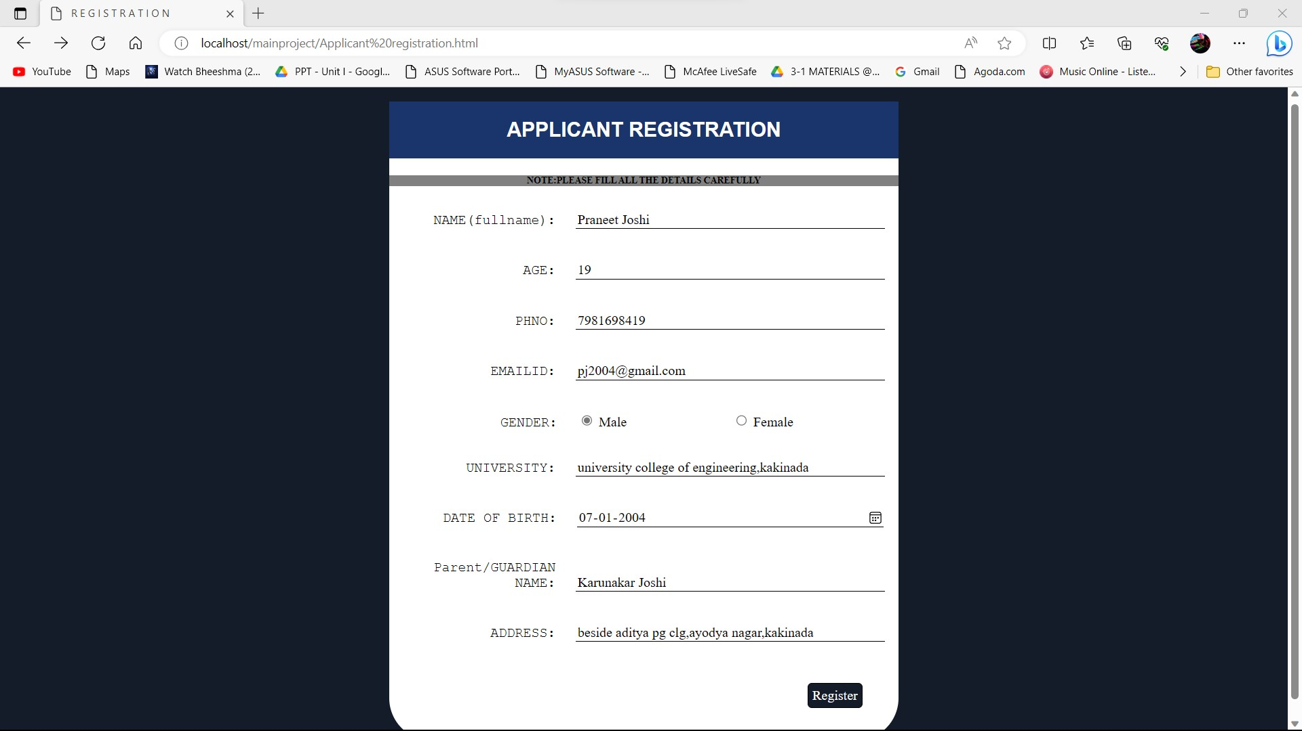

**PHP LINK TO HTML:**

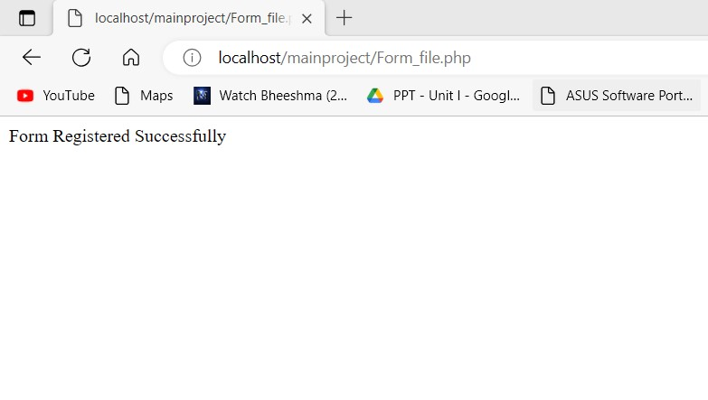

**DATABASE:**

**DATABASE NAME: mydb TABLE: applicant_data**

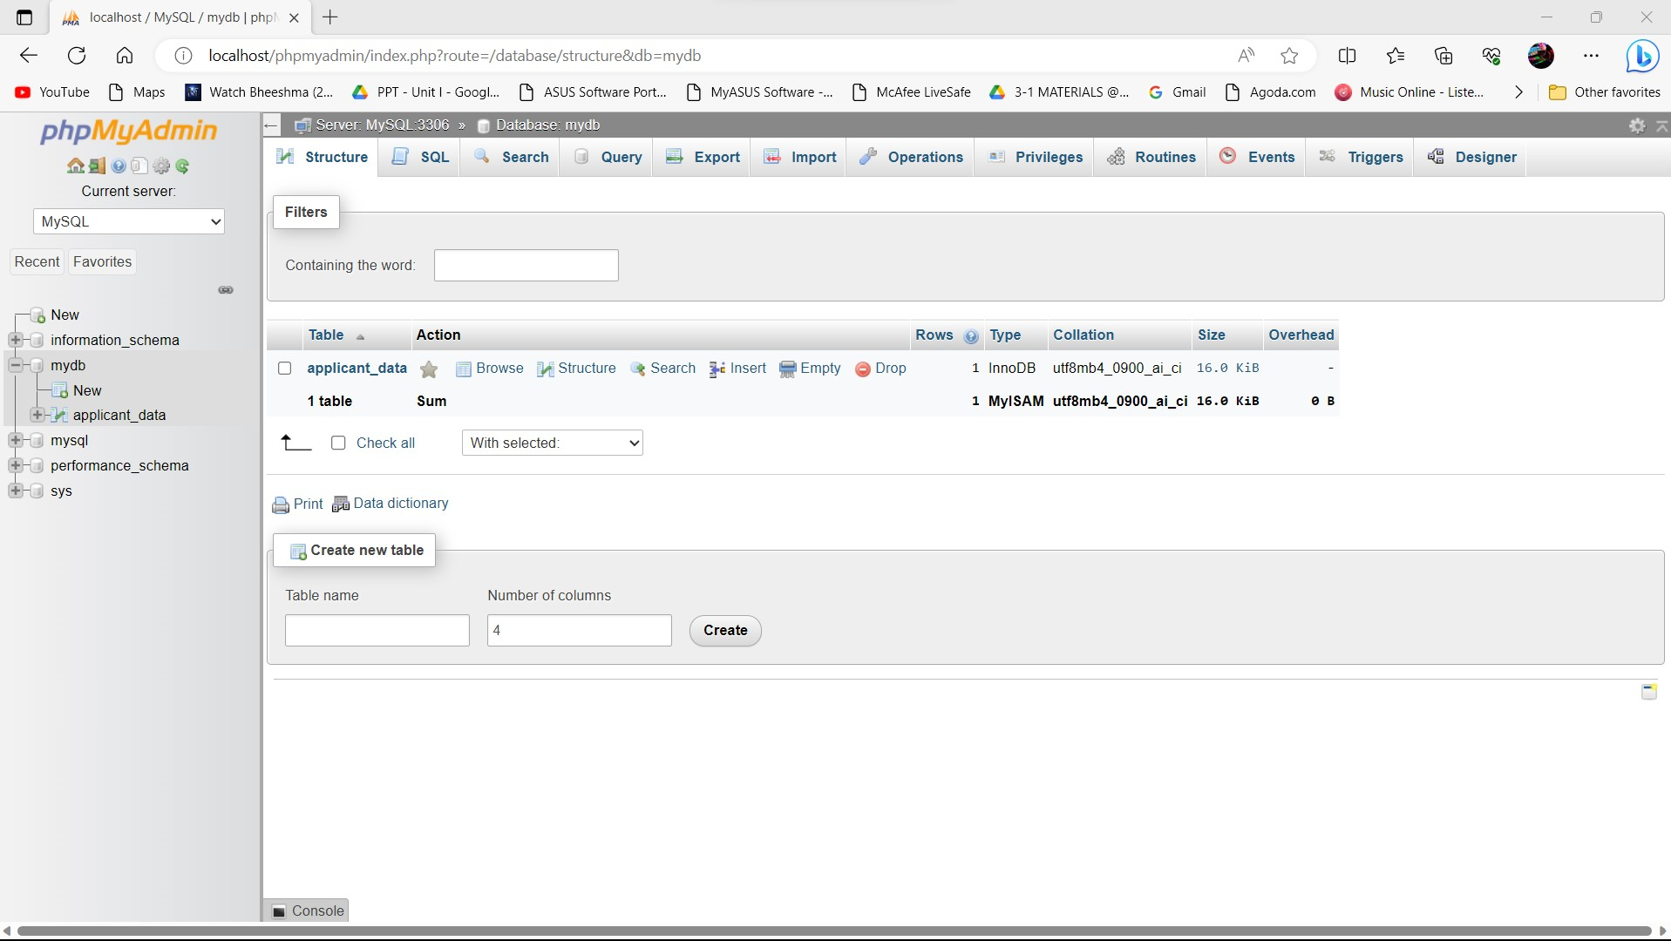

**TABLE STRUCTURE:**

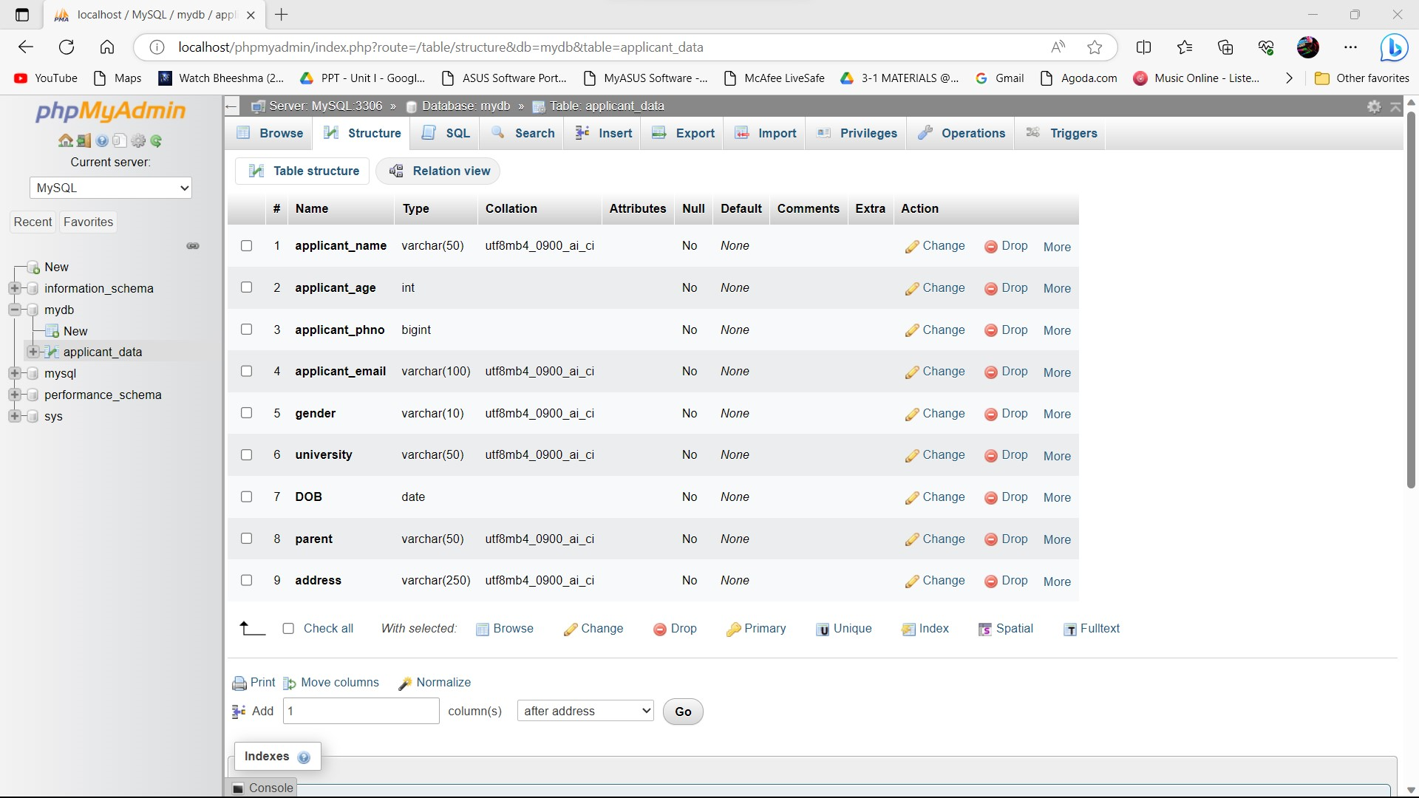

**STORED VALUES IN DATA BASE:**



